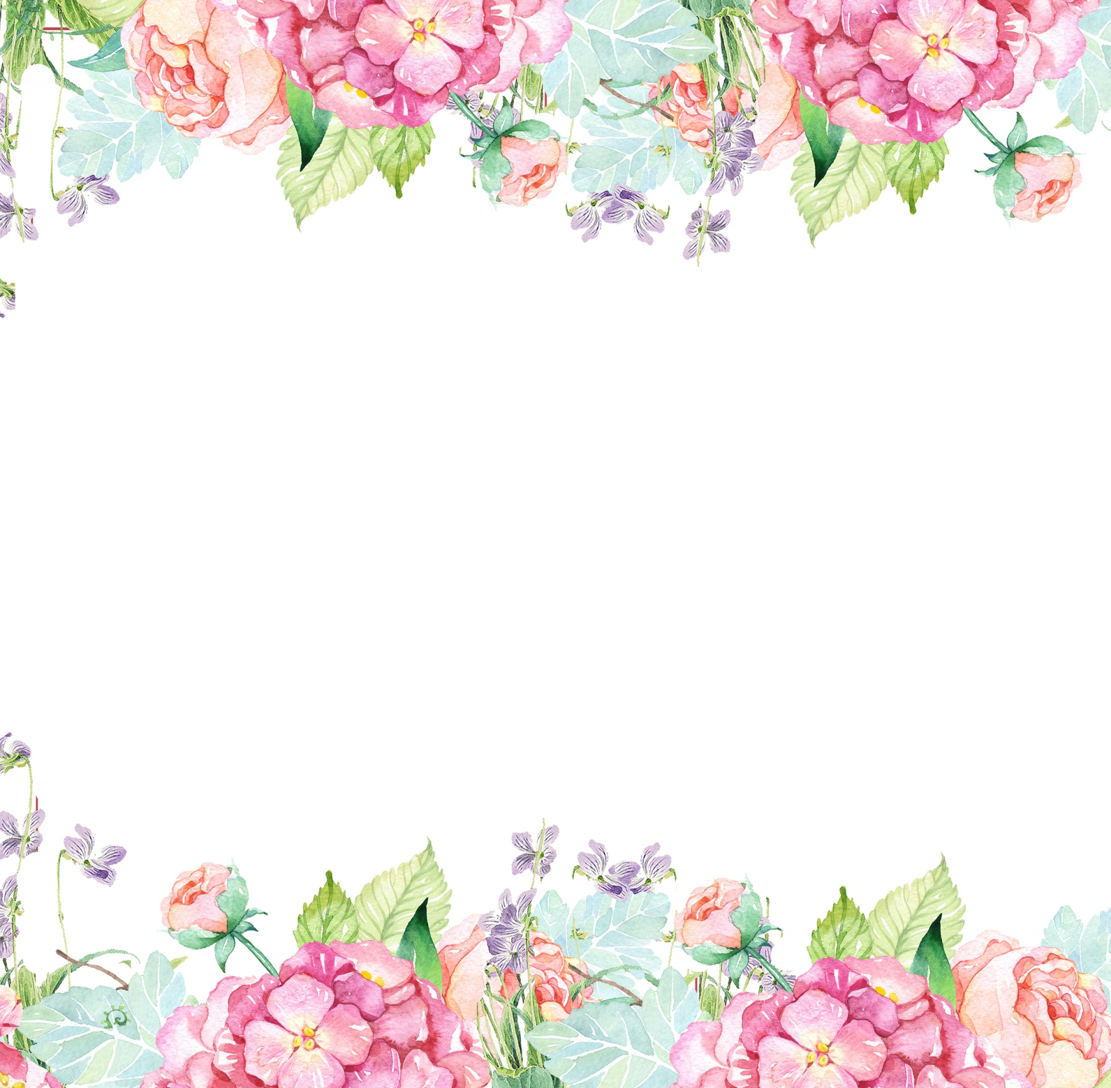

Name: Lisa Blackburn Initals: LDB

Birthday: *month & day only* 10/6

Preferred t-shirt size? M

What is your favorite color? Pink and Yellow

What is your favorite flower/plant? Hydrangea

Where are your favorite places to shop? Pink Narcissus, Target, Hobby Lobby

What are your favorite restaurants? Harry’s, Backwoods Crossing

What do you collect (candles, foxes, etc.)? Happy Everything

What is your favorite cold drink? Water, flavored water, Celsius

What is your favorite hot drink? Coffee with caramel

What is your favorite sweet treat? Heathbar, Normal Love Chocolate, Caramel

What is your favorite salty treat? Ranch Doritos, Pringles, lime and ranch mini ricecakes

What is your favorite fruit? Berries

Do you have any food allergies? None

Interests: Crocheting/Knitting

UMOJA House: Symponia

Wish list for your classroom? Expo Markers, Clorox Wipes